**Open Interest Secrets & Smart Money Footprints**

ICT got baptised by Ken Roberts for commodity trading

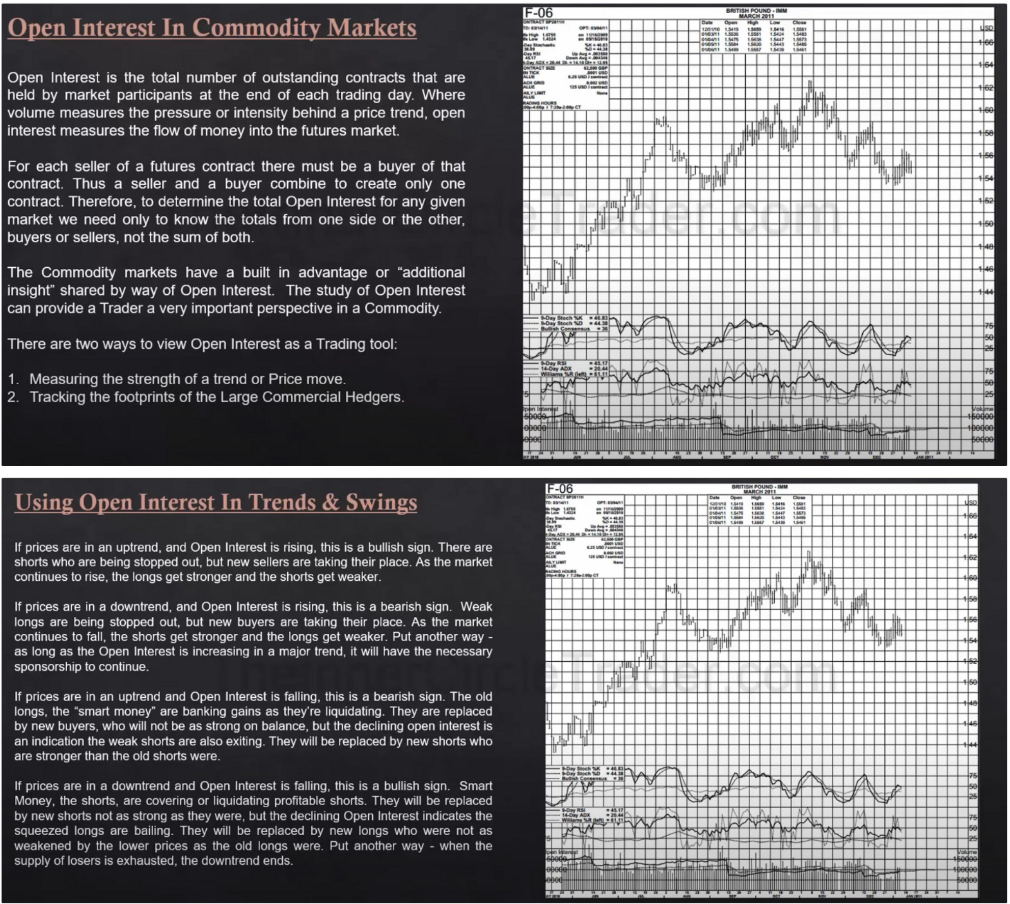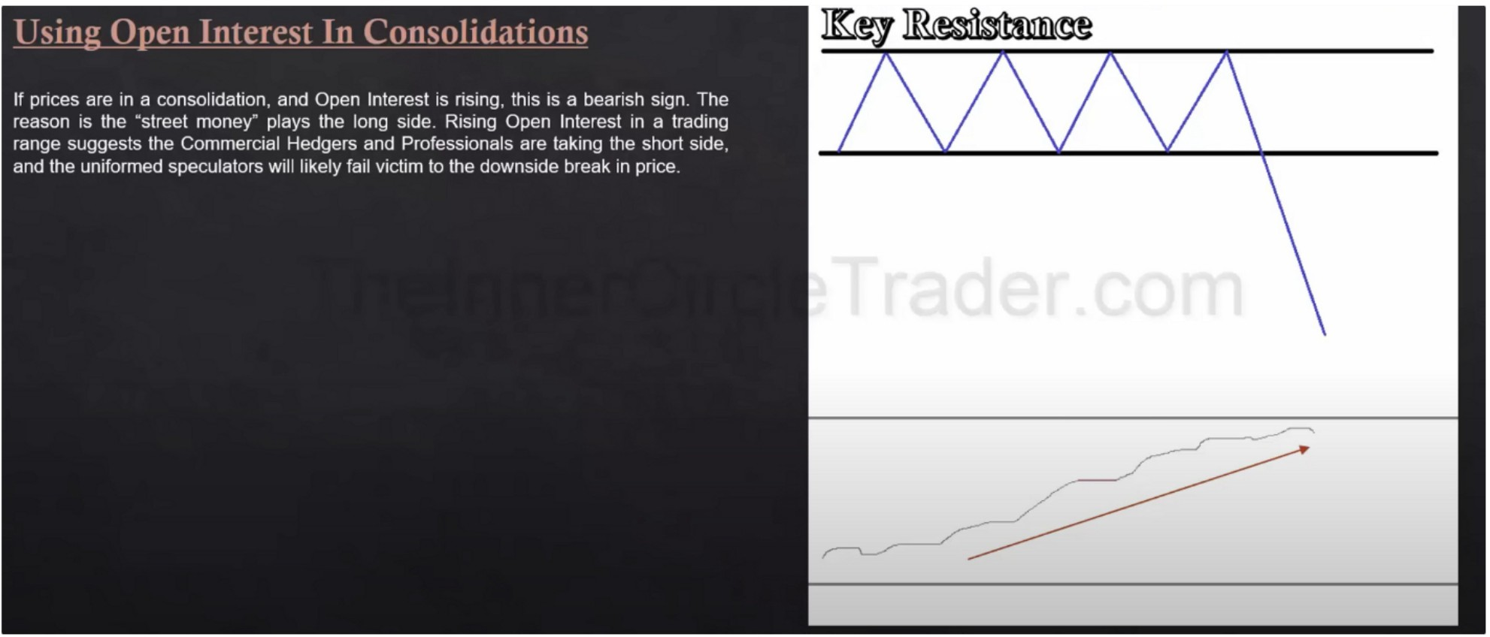

If open interest that means the banks have very high interest of seeing lower prices

When we see this we want to blend it with COT and or the net trader positions as a whole, in this case we want to see the commercials net short or increasing their short selling

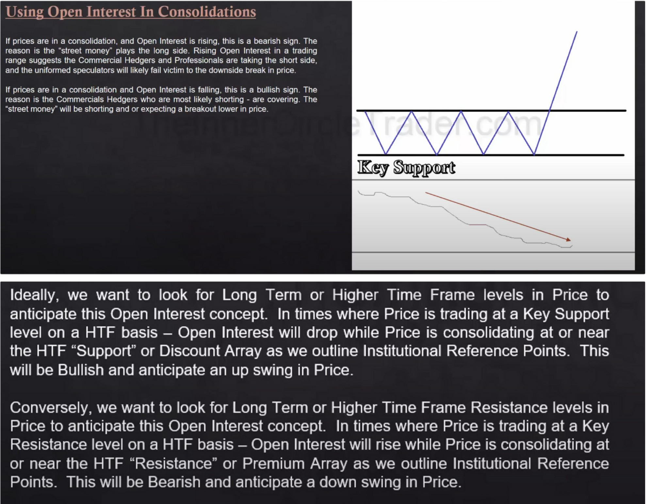

|  |  |  |  |  |  |  |  |  |  |  |  |  |  |  |  |  |  |  |  |  |  |  |  |  |
| --- | --- | --- | --- | --- | --- | --- | --- | --- | --- | --- | --- | --- | --- | --- | --- | --- | --- | --- | --- | --- | --- | --- | --- | --- |
|  | | | | | | | | | | |  | | | | | | |  | | | | | | |
| ....... | | | | | | |
|  | | | | | | |
|  | | | | | | | | | | | | | | | | | |
| U | N | 7 | M | 5 | U W **M** | 2 | 9 | U *n �* | 6 | U 211 *n* **4** | tt | U | 1 | I |  | *U* | *�* **6** | | U 211 *n* | 3 | U | N | 7 | M |
| IIAY2010 | JUN | JUL | **AUG** | SEP | OCT | NOV | OEC | JAN21111 |

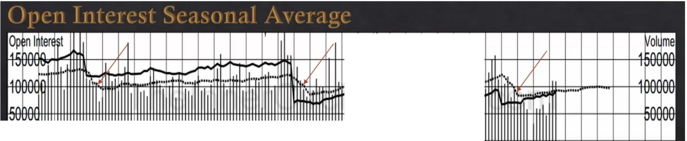Barchart.com total open interest and volume that will give you the true open interest for declines and rallies, but to get a better picture we're going to need more resources like CRBtrader.com and ricecharts.com if youre going to be a commodity trader, and it can even be used for forex analysis for quarterly shifts or mega trades then the idea is that we look at the seasonal average of open interest, both CRBtrader and pricecharts.com plot this for you.

The dotted line is the seasonal average and what over multi years open interest usually has done

If it goes above the seasonal average, we look at the differen between the actual open interest and the average to get a better idea of what commercials are doing, if we trade above the seasonal average at a resistance in a bearish enviroment that would be bearish. But when it drops down below the average that indicates the commercials are REALLY heavily covering shorts theyre well below the average, so if that happens and were at a support level in a bullish enviroment then that would be extremely bullish

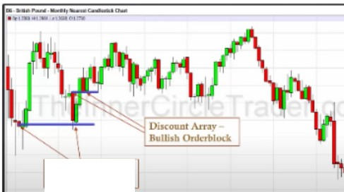

:

·-

I>i!ou,.•tAu••­

ll•lllD(J,,,de.t,lock

- - - ·

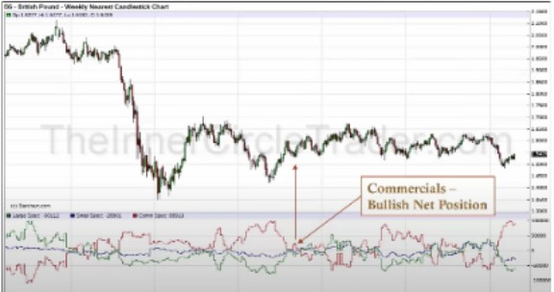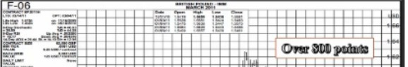

Open Interest Drops

At Support & 1n Range

.:.J-J .. w1i .. 111.i ..

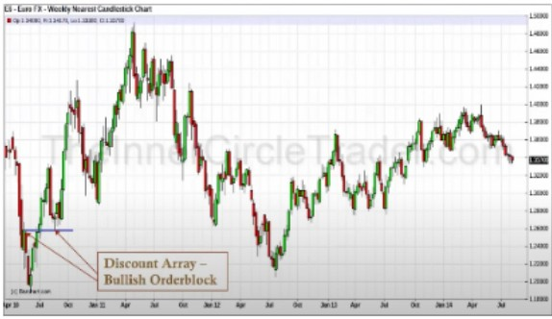

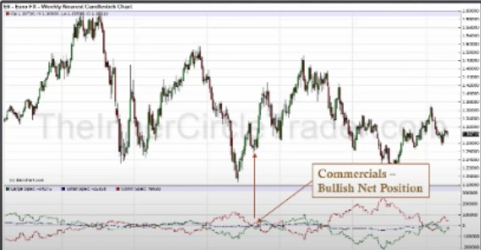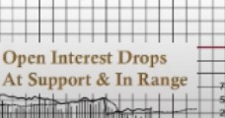

-10

t

Case studies

This works on the HTF basis, so position trading, swing trading, or to get your trading in sync with the larger move to a weekly premium array and while that is not fulfilled we can be looking to daytrade until the weekly premium array or an one shot one kill setup

Open interest has to be coupled with a HTF level

Using PD array matrix on the HTF charts coupling it with COT and with open interest we can anticipate much more stronger and more predictable moves. While it doesnt give a setup everyday, we can look for this because it happens a couple a times a year and when it happens we have all the timeframes at our disposal and can even benefit from it while scalping

Arjo I Twitter, lnstagram I Linktree

Linktree. Make your link do more.

, https://t.co/HhmmTN1fUI

JavaScript is not available.

*"'fl* https://twitter.com/arjoio